**Interview Notes**

* **Question: Can you tell us about your background?**  
  Goal: We hope to gain background and context for our project and how Dr. Anne is involved in this community.
* Anne
  + Grew up there
  + Co-founded organization
  + Initial interest in medicine started with the fact that growing up a ot of women who were pregnant was treated as a very somber time, knew that they would have a baby, but lots of women died of childbirth
  + Day going into labor, sad moment until the baby came out and the mother survived
  + Pregnant woman = “woman in-between”
  + Postpartum hemorrhage = largest cause of death in pregnant women
  + Make childbirth less dangerous, wanted a women/children health center
* Joanie
  + Volunteer
  + Gynecologic oncologist - cancer in the pelvis - surgery, chemo
  + Healthcare equity
* **Question: Can you tell us about the founding of Pothawira and the current setting?**  
  Goal: We want to learn about the location/community in which our device is being presented.
* Anne
  + Med school, went home to visit, working in a clinic with dad, a woman came in with baby and had walked 50 miles to clinic to get help, baby was so dehydrated but had no IV lines and baby passed away; women having babies on the floor, trash bags, postpartum hemorrhages
  + Med school friends - did garage sale, purchased land where
  + Pothawira = “safe haven” “a place to run to” Healthcare and infrastructure is broken
* **Question: What is your vision for how the implementation of the blood bank will help the clinic and the population of Salima?**  
  Goal: Understand the larger picture of what the blood bank (and the new devices that will come with it) is trying to accomplish within the hospital and OR’s grand scheme.
* Anne
  + Worked at gov hospital where all surgeries are being done
  + A blood bank usually has no blood
  + Center system in the capital system
  + The Minister of health will sometimes send some blood bags
  + Salima covers 560,000 people - only sent 10 units of blood per week from a central facility in the government
  + Within 20 mins of arrival, there is always someone in need of blood
  + Blood doesnt last even 24 hours
  + Want stocked blood bank, mobilize the community to understand the importance of blood donations - right now they only donate when people are in need of blood
    - Tested, match, bag, sets
  + Large part will be education on the necessity of donating blood
  + Cholera outbreak a year ago, didnt have IV things
  + Pediatric patients - Malaria is #1 cause of death in kids under 5
    - Parasite lyses RBCs, children become very anemic, very common
    - Kids with sickle cell don't survive (I wonder if storing/taking sickle celled blodd is any different then cup celled blood)
    - ^^u should ask as a follow up
  + 29% of pregnancies in Malawi happen in adolescence
* Joanie
  + Don't have blood giving set - people die all the time from this
  + Store and give blood directly to 4 operating rooms running and to birthing center and clinic
* **Question: How does the government help/hurt running a successful medical facility?**  
  Goal: Understand how government regulations and spending affect their ability to run a medical facility
* Anne
* Help
  + Donor driven gov help
  + Donor country attracted to funding - gov help comes in
  + Large donors to HIV, HIV counselor paid by gov, treatment is free from gov, well funded program, funded by donors all over the world, get services for HIV that don’t cost extra money, drugs are free
  + Malaria is not as funded as HIV, meds/testing/treatment
  + Donors drive what the government is able to help with, only help in the most funded program
* Hurt
* Money is a huge concern, poor country, have more evident corruption
* Come in as private clinic, assume you have a lot of money, charge huge fees
  + Started building surgical center, decided that they want every building to be approved by gov, set up meetings for people to approve them, budget of building, want 10% of budget to be used as approval times (70k), decreased cause
  + Average person makes 1.25/day
  + Fees and charges prevent projects from occurring
* **Question: What component of the blood-giving sets would you say is the limiting factor?**  
  Goal: Find out which components of the blood-giving sets are most crucial to be reusable.
* Anne
* Part of the tubing, bag and tubing
* Bag where they can collect blood, find ways around that
* Tubing can't really clean
* Ask maggie
* Don't have bags, but usually don't have the actual giving set, have to go to capital which is 2 hrs away
* Joanie: Can't connect blood and recipient
* **Question: How much blood do you intend/expect to be stored at the same time, and how many blood donations do you expect to receive in a day?**  
  Goal: Get a gauge on how many of these sets they will need.
* Anne
  + Everybody getting surgery has to donate blood
  + Fridge with enough blood to run OR (Need to think about the shape of our storage to fit the best in the refrigerator)
  + 5 - 6 donations of blood a day, each patient would have a donor
  + C sections when come in would have to have pre donated blood
  + Now most people only give blood when family member needs it, will have lots of education implemented to increase blood donations
  + FOLLOW-UP– what would be the best way to get the community to understand the importance of donating blood
* Joanie
  + 4 ORs, each room does 3 surgeries a day at max capacity, each surgery needs to have at least 2 units of blood available = inflow needed on daily basis
  + C Section room - 5x a day, 2 units for each = 10 units for just C sections (at least)
  + 4*3*2 = 24 units of blood a day, each patient getting 2 units, can have 2
  + 25 units of blood on fully functioning operating day
  + Do they have the resources to store the blood? Or do we need to assume that our device is going to also be the storage container for all the blood?
* **Question: What do you use to sterilize your equipment currently, and/or if that will change in the future? What do you expect the new OR will have in terms of sterilization?**   
  Goal: Learn about the sterilization process used to understand how our design will be sterilized and what we need to prepare them for.

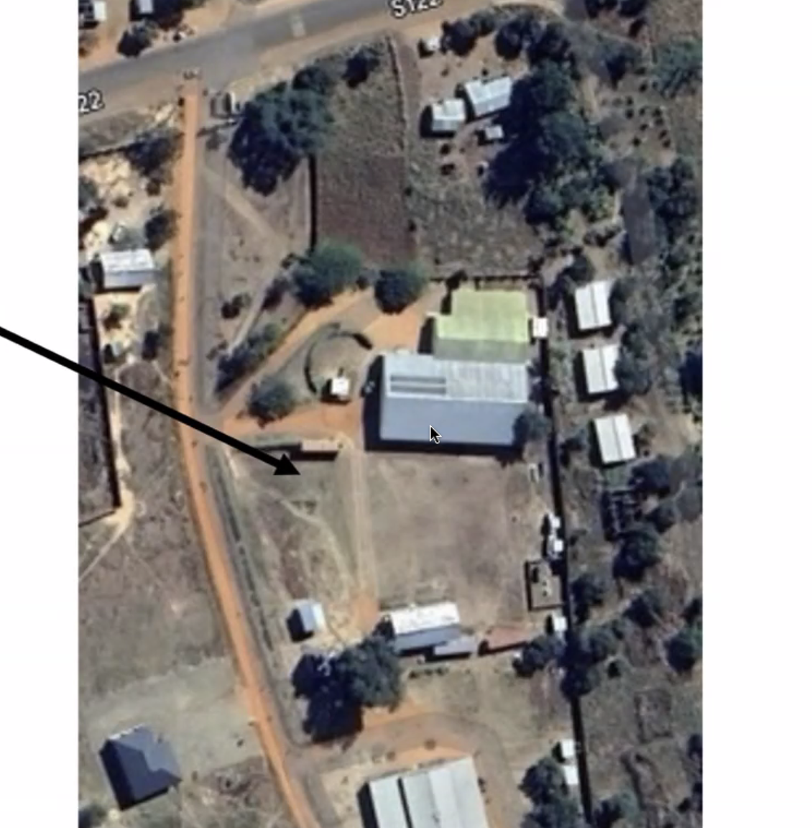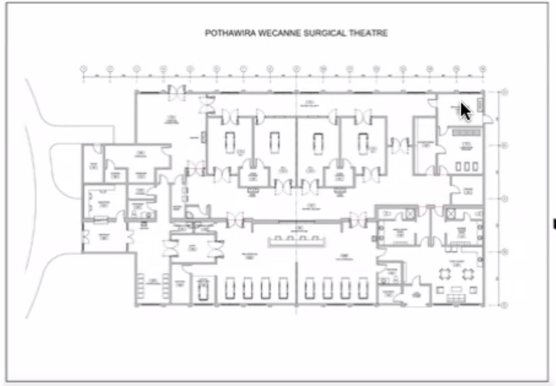

* Mouse over dirty room, washers go into second room, get washed at high temp and dried, get packaged into units and sterilized then stored
* Same in the US
* 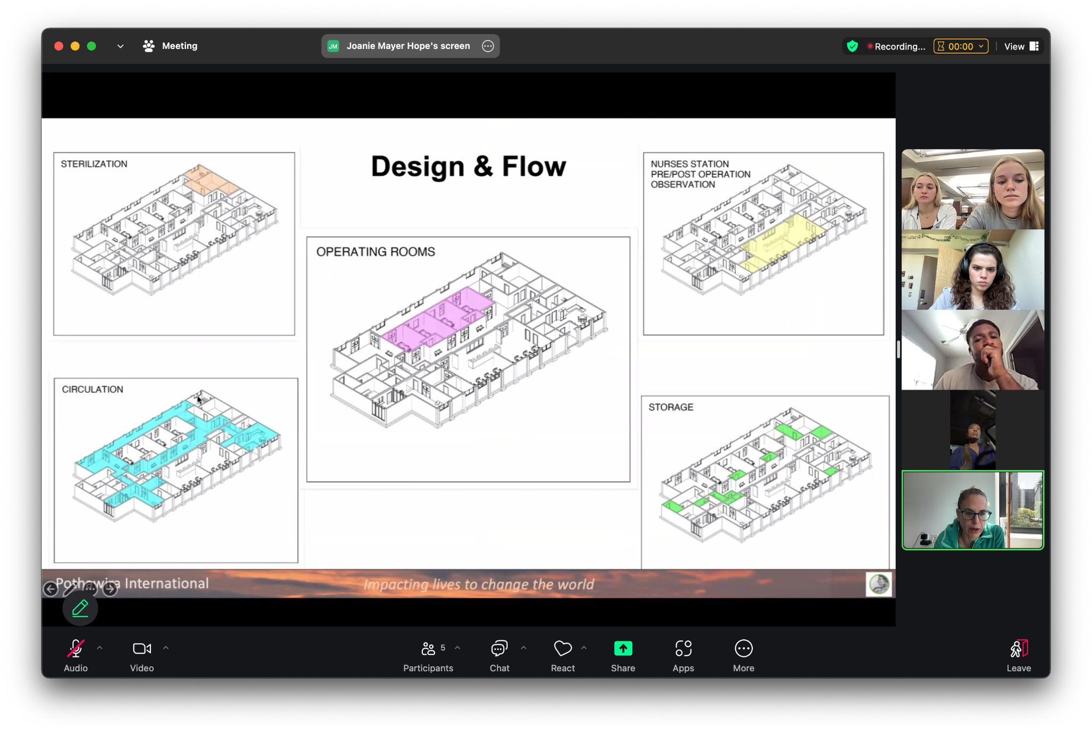
* Machines, going to be very similar to a US system

Donate blood, centrifuge into diff parts

Malawi, test blood, give bag of blood, give to next person

Going to do whole blood system rather than centrifuge

Pint/bag of blood, store blood for a few months,

Way to store blood then transfer to reusable units when its time to give it

Plug into bags they have with our reusable units

Store blood and squeeze it into bag that we make

* **Question: We want whatever we make to be reproducible. Do you know what tools/technologies the engineering students at the Malawi Polytechnic Institute have at their disposal?**  
  Goal: While we may only be able to make one or a few of these sets/ warmers, we want to be able to pass on this project to biomedical engineering students at the local university. Anne has already expressed that she could connect us with them.
* BME program, has worked with Rice University, came up with a portable high oxygen unit
* Work on prototype, could talk to them

**Mock Interview**

* **Question: Can you tell us about your background?**
* Emergency physician, went to med school with anne
* Works there, financially supports project for last 20 years
* Made 4 trips there

Goal: We hope to gain background and context for our project and how Dr. Anne is involved in this community.

* **Question: Can you tell us about the founding of Pothawira and the current setting?**
* Located in Salima district of Malawi (one of the poorest countries in the world)
* Started with Annie growing up there, she and parents bought plot of land, opened clinic and orphanage,
* 125 orph
* 300 patients at clinic
* Birthing center, building 4x ORs
* Distict hospital has onlty 1.5 ORs for everyone, lots of people dying due to lack of access   
    
  Goal: We want to learn about the location/community in which our device is being presented.
* **Question: What is your vision for how the implementation of the blood bank will help the clinic and the population of Salima?**
* Problem: have 1.5ORs in hospital
* Must show up with relative for blood donor or cant do surgery
* Blood bank cant store blood and dont have blood giving sets
* Lose too much blood, cant do transfusion, potentially die even in biggest cities because they dont have blood giving sets or a way to store it

Goal: Understand the larger picture of what the blood bank (and the new devices that will come with it) is trying to accomplish within the hospital and OR’s grand scheme.

* **Question: How does the government help/hurt running a successful medical facility?**
* Government is corrupt
* Whatever village the gov officials are from, divert any resources ot that village and take them from other villages
* Closed off to competition
* Cannot supply power to entire country
* Send power to politicians home villages
* Neighboring countries could bring power but government won't allow it
* Deterrent in getting better healthcare resources to country

Goal: Understand how government regulations and spending affect their ability to run a medical facility

* **Question: How have the solar power panels donated by Japan changed the adversities faced by inconsistent electricity? Given this context, Ideally, would the product work independently of the electricity, or has this grid been enough support such that our product could rely on wall power/generators?** 
  + Solar panels are being installed in the surgical center
  + Hoping ot use solar power for energy and not have to depend on gov for energy   
      
    Goal: Understand how the utilities have been affected by this donation and what context may be important for power sources.
* **Question: What component of the blood-giving sets would you say is the limiting factor?**
* **for reusability
* 1. Storage bag
* 2. Tubing
* Needle   
    
  Goal: Find out which components of the blood-giving sets are most crucial to be reusable.
* **Question: How much blood do you intend/expect to be stored at the same time, and how many blood donations do you expect to receive in a day?**
* Unsure, specific to hospital
* Surgical center building 4 ORs
* People building surgical center don't know how to run a blood bank bc never done it before
* Need help and education on how to store blood
* Know how to operate haven't run a blood bank   
    
  Goal: Get a gauge on how many of these sets they will need.
* **Question: What do you use to sterilize your equipment currently, and/or if that will change in the future? What do you expect the new OR will have in terms of sterilization?**
* Unsure, specific to on-site people
* Clinic doesnt sterilize things very much
* Sterilizer machine
* Antiseptic solution that they put in beakers
* Have sterilizers coming from the US for the surgical center   
    
  Goal: Learn about the sterilization process used to understand how our design will be sterilized and what we need to prepare them for.
* **Question: We want whatever we make to be reproducible. Do you know what tools/technologies the engineering students at the Malawi Polytechnic Institute have at their disposal?**
* Unsure
* One of the orphan kids just started engineering there – should talk to him – ask anne   
    
  Goal: While we may only be able to make one or a few of these sets/ warmers, we want to be able to pass on this project to biomedical engineering students at the local university. Anne has already expressed that she could connect us with them.
* **Question: How do you anticipate the infection rate of HIV/AIDS and other current health trends in Malawi affecting this project?**
* Need to know more about blood testing for diseases
* Test for HEP-C, HIV
* More people getting treated, not as big of a problem
* Testing is not as extensive   
    
  Goal: Understand current health trends in Malawi and how to account for them in the planning of our project if necessary.
* May need context on scope of project

More questions: